HW 6 Phys 305 Christopher Morris

Q1:

a)

 Question 1a Matrix Method

Eigenvalue = 0.9999992653331015 with Error = 7.346668985386273e-07

Eigenvalue = 2.9999963264633402 with Error = 3.6735366597540065e-06

Eigenvalue = 4.999990449009822 with Error = 9.550990178297525e-06

Eigenvalue = 6.99998163268579 with Error = 1.8367314210010477e-05

Eigenvalue = 8.99996987995935 with Error = 3.012004065006124e-05

Eigenvalue = 10.9999552150504 with Error = 4.4784949599474544e-05

Eigenvalue = 12.999937861523735 with Error = 6.213847626490576e-05

Eigenvalue = 14.999919506571365 with Error = 8.049342863536424e-05

Eigenvalue = 16.999910714109333 with Error = 8.928589066670156e-05

Eigenvalue = 18.99996693732435 with Error = 3.3062675651507334e-05

A grid size of 3500 was used

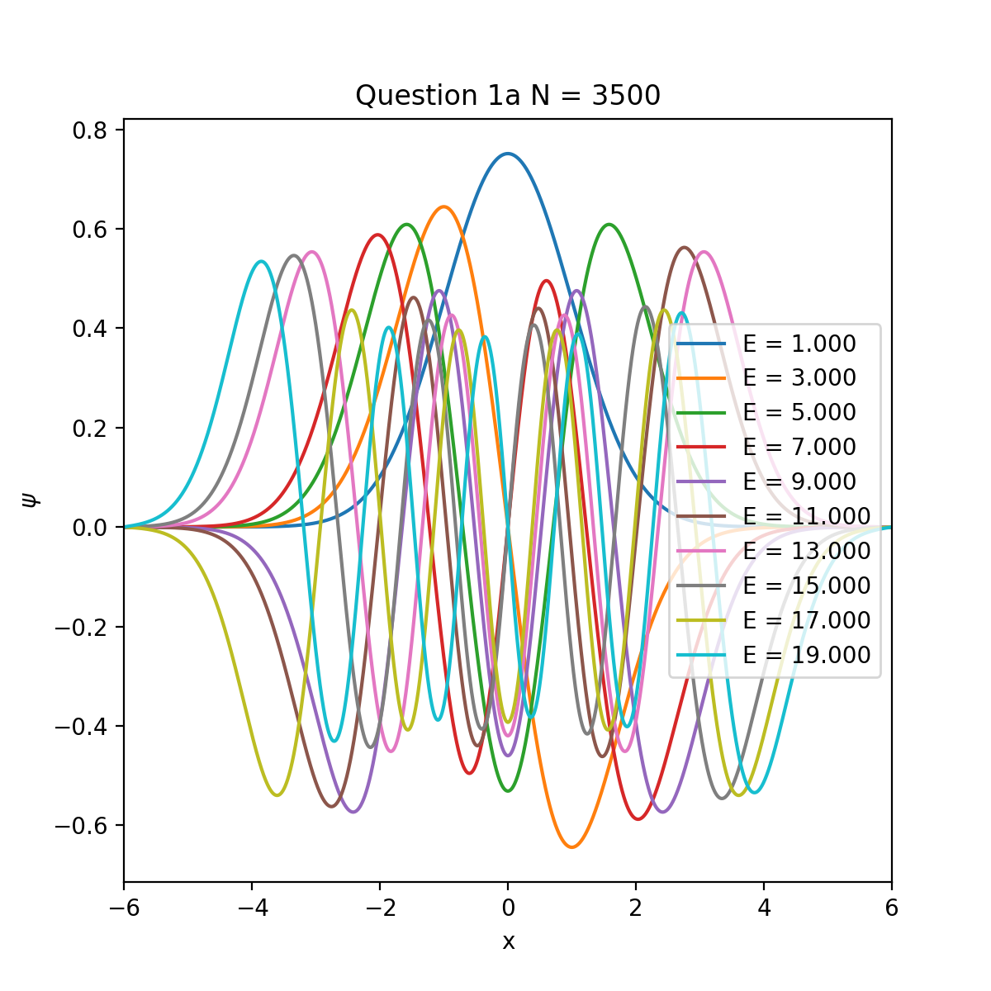

b)

Question 1b Numerov Method

Eigenvalue = 0.9999999936719797 with Error = 6.328020329959827e-09

Eigenvalue = 2.9999999556947805 with Error = 4.4305219493168124e-08

Eigenvalue = 4.999999841770567 with Error = 1.5822943311150084e-07

Eigenvalue = 6.99999960138641 with Error = 3.986135901357102e-07

Eigenvalue = 8.999999185976883 with Error = 8.1402311735701e-07

Eigenvalue = 10.99999856913266 with Error = 1.4308673392804394e-06

Eigenvalue = 12.999997923947692 with Error = 2.0760523078422466e-06

Eigenvalue = 14.999998886921773 with Error = 1.1130782269219708e-06

Eigenvalue = 17.000011971863593 with Error = -1.1971863592918908e-05

Eigenvalue = 19.000092586359003 with Error = -9.258635900266654e-05

A grid size of 400 was used

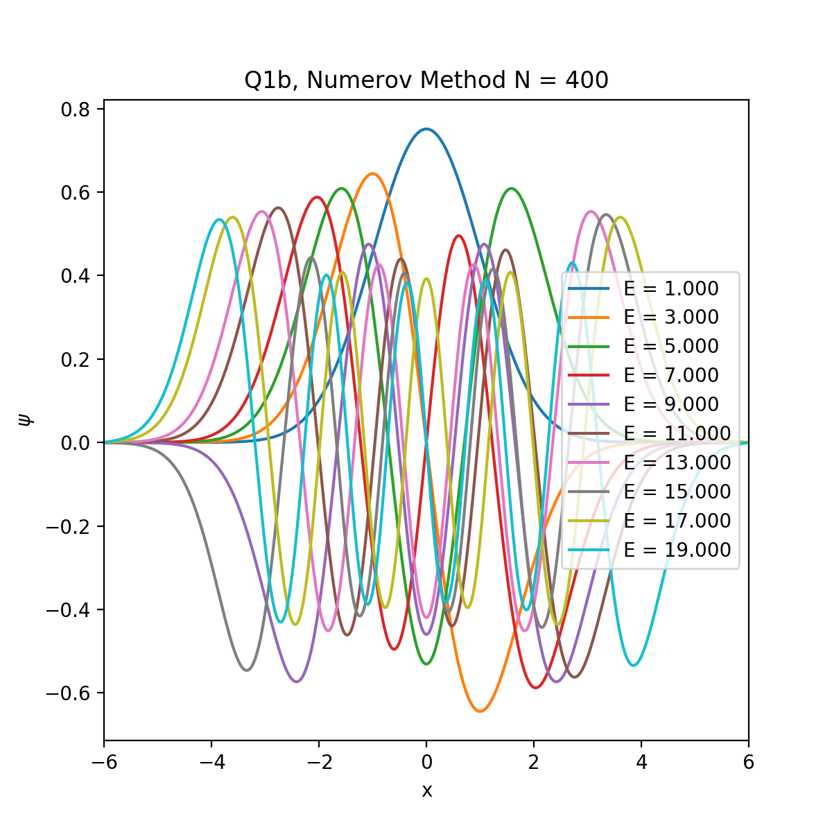

2)

A range from [-120, 120] with a grid size of 2500 was used

 Question 2

Eigenvalue = -0.303591787578612

Eigenvalue = -0.057977394113571654

Eigenvalue = -0.021432254626232605

Eigenvalue = -0.0033419619266411424

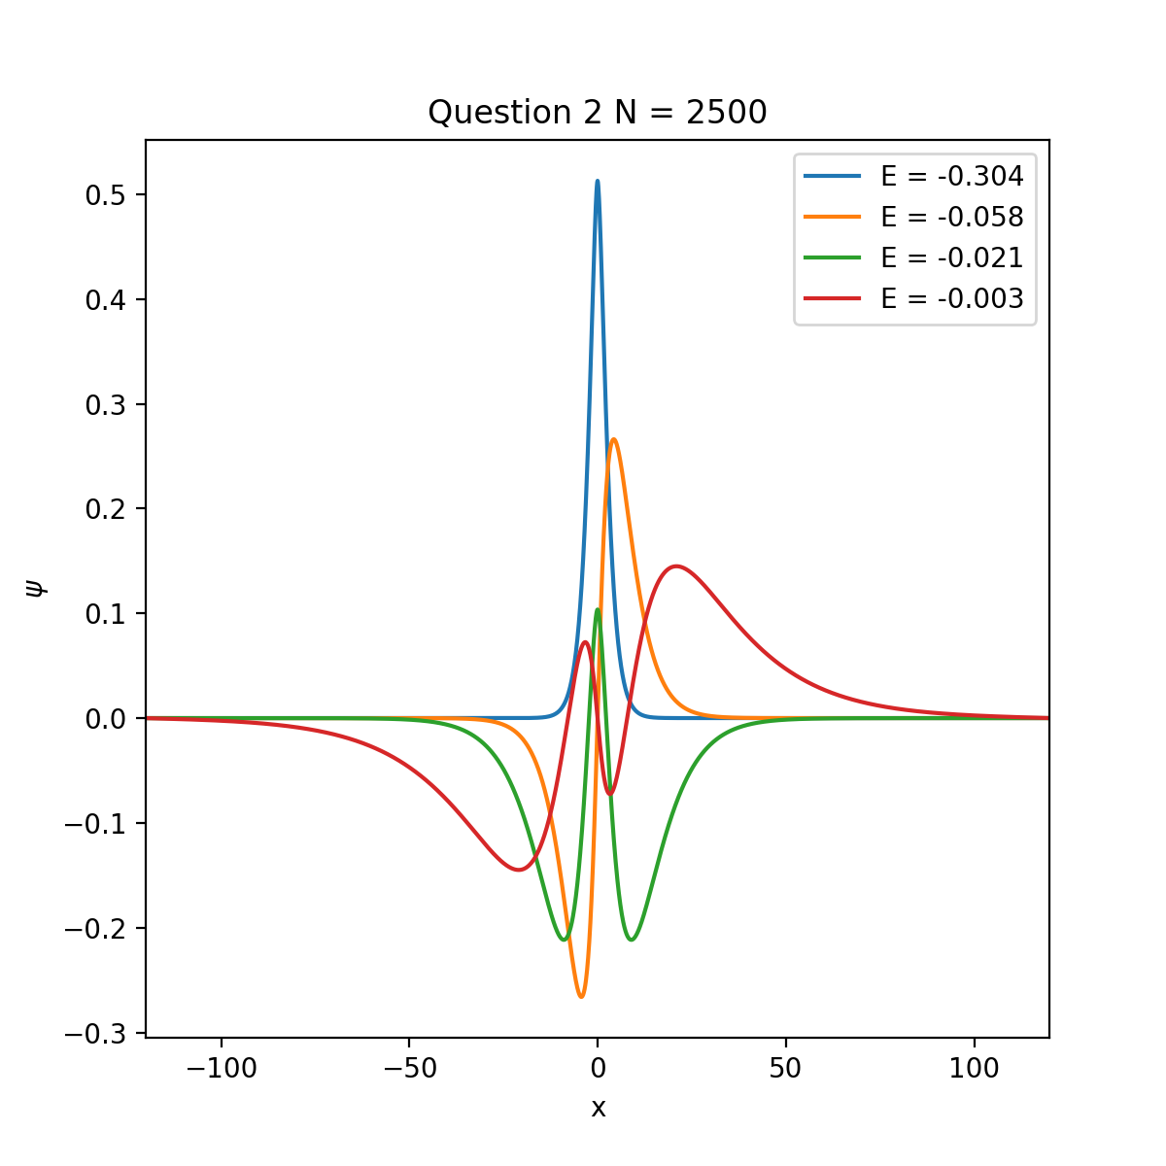

3)

l = 0

 Question 3

l = 0

Eigenvalue = -13.595374039379589

Eigenvalue = -3.3994216860316744

Eigenvalue = -1.5109397518704422

Eigenvalue = -0.8499276731465116

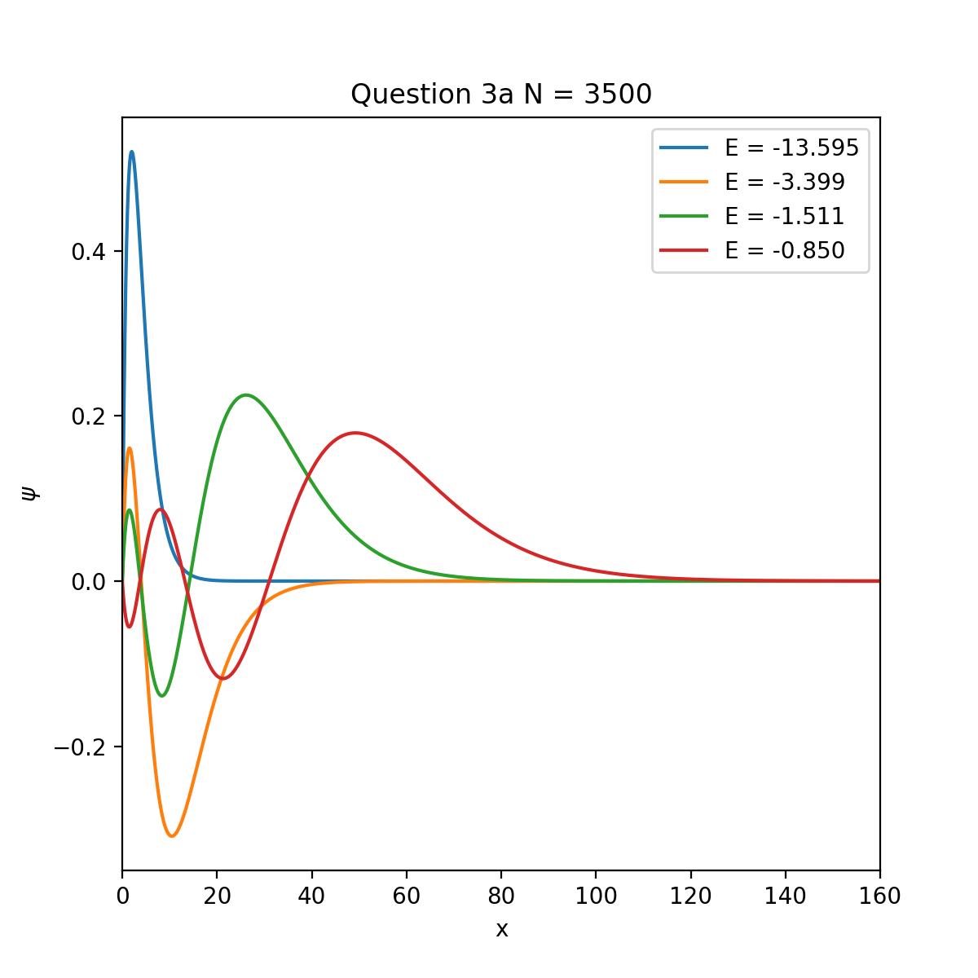

l = 1

 Question 3

l = 1

Eigenvalue = -3.400001557608964

Eigenvalue = -1.5111116582292368

Eigenvalue = -0.8500002211831307

Eigenvalue = -0.5438799591045504

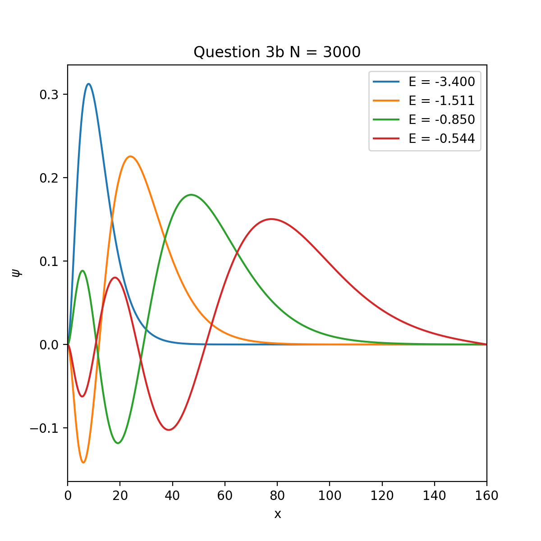

Remarks on Graphs:

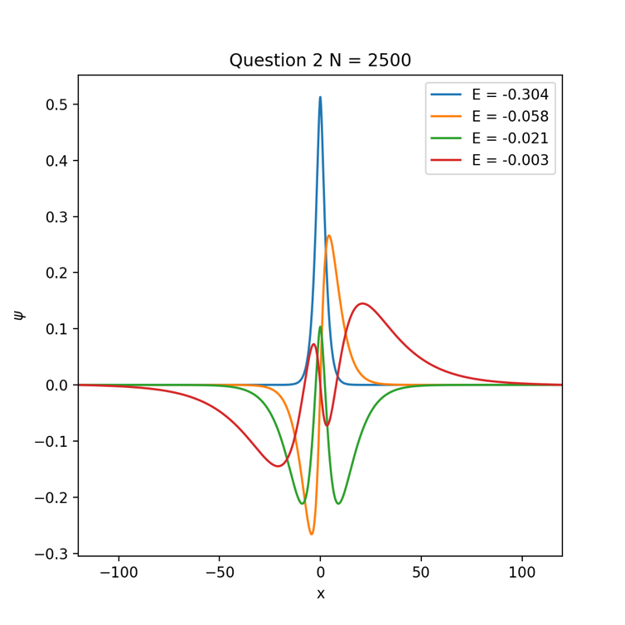It was noticed that different eigenfunctions would be returned when using the np.linalg.inv and scipy.linalg.inv. For the answers, scipy.linalg.inv was used; however, some of the eigenfunctions (but not all) were reversed compared to others when looking at their graphs. I don’t know why this happened, but these where are two graphs using the different inverses:

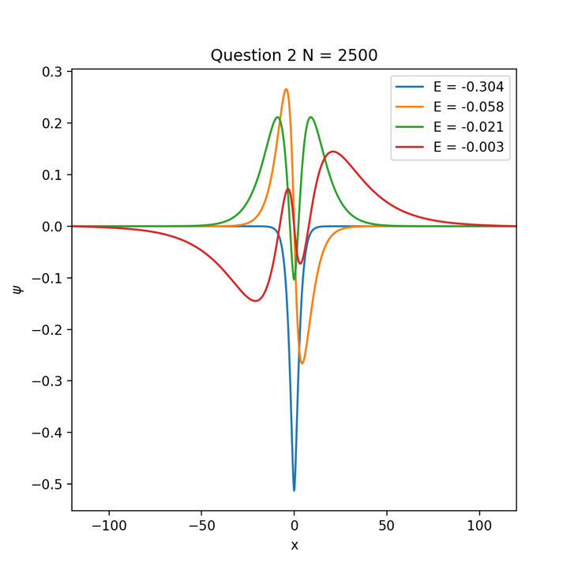Scipy.linalg.inv np.linalg.inv